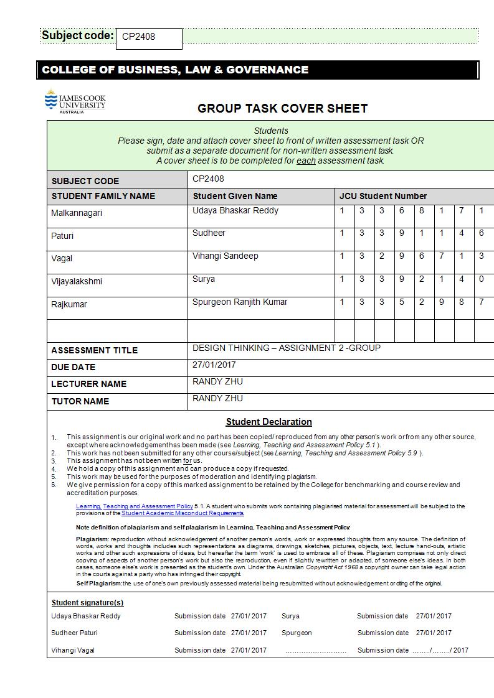

**Design thinking – Group Submission**

**Team Members:**

Udaya Bhaskar Reddy – Team Leader

Members:

Sudheer Paturi

Vihangi Vagal

Spurgeon

Surya

**Dynamics of the Team:**

In order for a team to perform in an effective manner, the role of each member must be defined in an accurate way so that it helps the group function as a single unit. Different group members are like individual parts of the same machinery. The machinery will depend on each and every part for its overall functionality. Even if one part fails, it will result in the failure of the entire working mechanism.

Our team has been very collaborative during all the stages of project development. Our work represents the hard work put in by all the team members towards a collective goal. There was always a sense of inner appreciation for each other for fulfilling our individual tasks. The functioning of the group was cordial and cohesive, and helped in reaching our set targets sooner than we initially anticipated. The majority of our work force is expended on channelizing our energies upon our specific set goals. Each member was allocated different roles at every stage of development and the team leader acted as a key coordinator in helping the team meet its intermediate goals and then later move on to the next task.

**Assigning roles:**

The key element in assigning roles within the framework of a group is to identify the individual strengths and weaknesses of each group member. Our group felt it was an essential step in allocating roles amongst each other. It is important for all of us to understand the talents of each group member and use them effectively during all the stages of development. For this purpose, the team undertook a personality test. The results of the test can be referenced in the previous section. These personality tests were extremely beneficial in analyzing the core character traits of each individual group member. The results of the personality tests and their significance in allocating roles is explained below along with the roles performed by each individual group member during the three iterations

**Team member Uday – Team Leader (The Campaigner)**

This member’s personality test revealed his social and diplomatic skills, and his highly enthusiastic and creative nature. Our team felt he would be an ideal choice for the Team leader as he had the ability to coordinate effectively with all the group members. Furthermore, his creative nature will be an added bonus in helping the team move on the right track during the course of the project. Our group feels his performance during all the stages of development has been exemplary. He forms the core part upon which our machinery functioned. He acted as the central point of our working system. He was the “go-get” guy for the group. If any group member had a difficulty in understanding a particular task, he was the first one to be approached. If he could resolve it himself, he would do it or else, he would organize a meeting and asked the suggestions of the group on how to move forward. This shows the collaborative nature of our team in general.

***Storyboard and Sketching:***

This member’s creative skills were utilized to the fullest during the Storyboard sketching. He was allocated the role of writing the script for our Storyboard. His drawing skills also came into play while making the initial sketches. This was very helpful for the team to understand and move forward while making a digital version of the Storyboard. He played a key supportive role in helping the other group member Vihangi , who was assigned the task of making the Storyboard.

***Interviews and User Testing:***

This member conducted interviews and user testing during the three phases of iteration. One of his interviews revealed a key feature for our application. The person he user tested was extremely interested in the agent certification mechanism incorporated within our app. Our group tried to emphasize on this idea in further iterations.

***First Iteration:***

This member was assigned the role of a “Designer” during the first iteration. As mentioned before, he was extremely skillful in making paper sketches, and our team utilized it effectively by allowing him to make his own initial designs. They were later reviewed by the entire team and changes were incorporated accordingly. He, along with another group member, Sudheer, worked extensively during the first two stages of designing the prototype. It was a collaborative work from both these members that achieved the final goal. All the prototype designs and drawings were done as part of a coordinated work of both these group members.

***Second Iteration:***

This member continued with the role of a “Designer” during the Second iteration. This iteration was an improved digital version of the previous iteration and the team felt the need of the expertise of this group member to perform this task. As he is already familiar with the basic design of our app from the first iteration, our team felt that he should perform this task to make the transformation to the digital stage much more effective. His knowledge and understanding of the “Balsamiq” software (which the team used to make the digital prototype) made us complete this task at a faster pace.

***Third Iteration:***

This member played a supporting role during this phase of development. As he was involved with the designing part of the first two iterations, he collaborated with another group member, “Surya”, to finish the final design of the prototype. He was assigned the task of making sure that appropriate changes were made in the final design based on user testing.

To sum it all up, his roles both as a Team leader and a Designer was crucial in finishing our project on time.

**Team member Sudheer – Supportive system (The Mediator)**

This team member’s personality test revealed that he belongs to the mediator category. He acted as the basic support system of our group. His skills in understanding the intricacies of mobile apps were put to good use during the iteration phase. His main role was to help create a Cohesive Environment within our group. In case of any conflicts and differences between the group members, his role in mediating and resolving them in an amicable manner was commendable.

***Interviews and User Testing:***

This member conducted interviews and user testing during the three phases of the iteration. His interviews were extensive and helped the team understand the core necessities of an immigrant in a proper manner. His interviews were recorded as audio transcripts which were then played during the team meetings. Our team was pleasantly surprised when we heard the interviewee expressing satisfaction at one of the assumptions we made. This assumption includes one of the core features of our app, to search a house near an ethnic community.

***First Iteration:***

This member played the role of a “Designer” during the first iteration. His knowledge and understanding of mobile apps came to the fore during this phase. He was able to guide the team in incorporating minute details in our design layout. Little details like adding a ‘Menu’ button to the left instead of the right were suggested by this member. He uses a wide array of mobile applications in his everyday activities. He also revealed his passion to choose ‘Mobile Computing’ as a career during one of the team meetings. The team realized his importance and used his expertise to good use. All the design layouts for the ‘Properties’ pages and the ‘Registration’ pages were done by this team member. He has also done extensive research on various mobile apps available in the market to utilize some of the good features in our final design.

Tools used during first iteration: a number of property apps that are available in the market and took some of the designs as inspiration for designing the interface of the app the team is making. He used paper, scale and pencil to sketch the first iterations drawings and prototype.

***Second Iteration:***

This member continued with the role of a ‘Designer’ during the second iteration. The digital medium was more exciting for him as he had the tools now to make it simulate the look of an actual working version. He main design includes the layout for the ‘Properties’ page and the ‘Menu’ page. He assisted the other group member ‘Uday’ by helping him design the ‘Search by Interest’ page. He suggested using a map will be the most effective way of letting the user know the exact location of the house. It reduces the effort from the user’s side while navigating through the application. He proposed the team to use images in the second iteration itself as more interactive tools(marvelapp.com) can be used for the High-Fidelity version. His idea was discussed within the group sessions and finally got the approval of the whole team.

***Third Iteration:***

He played an active role again during this phase of project development. He assisted the other group member ‘Surya’ by helping him understand the design changes that needs to be made for the final iteration. The third iteration was a collaboration between these members along with inputs from the leader. The basic color theme that was added in the end was an implementation of his idea. He was also assigned the task of incorporating the app within the www.marvelapp.com framework to make it interactive to the end-user.

This member was the main branch of the supportive system that the team relied upon. The work and effort spent by this member on the overall project is praiseworthy. One thing that makes this member special is his availability at all the times of the day.

**Team member Vihangi – The ideas system (The Entrepreneur)**

This team member’s personality test revealed that she falls under the ‘Entrepreneur’ category. She is highly energetic and very perceptive. She has a wide assortment of skills that were used by our group effectively. One of her main talents to storytelling. She is interested in conversing with people and analyzing the various aspects of human behaviors. This made her an automatic choice for the team to assign her the task of Storyboard sketching.

***Role in Storyboard Sketching:***

Based on the assumptions and hypothesis that our team came up with, the task of summarizing the events in a little story was assigned to her. Our group already created three proto-personas which were to be used as characters in our Storyboard. She along with the team leader ‘Uday’ worked on this aspect of our design. Our team identified the core issues an immigrant faces during their ‘settling in’ phase. But the hard part was incorporating these ideas in the form of a story. And making a conversation relevant was the tricky part. An example of one such user-experience is illustrated below.

Our team wanted to incorporate the design of ‘fake agents’ in our final design. Our user testing also revealed that the user was satisfied with this feature and considered it relevant. However, further research on the topic revealed that ‘fake agent’ filtering is not required in the context of a country like Singapore. We wanted to omit the feature, but this member suggested minor changes that would boost the overall design based on this feature. Her intuitive nature helped us understand the problem and change it according to the perspective of the user. Our team finally decided to use this feature with additions like ‘rating’ the agent and giving the users a chat option that would increase the overall usability of the app.

***The ideas System :***

She was the basic ‘ideas’ system that the team relied on when it came to making the smart decisions. As mentioned before, she tries to adapt her ideas with respect to the needs of the user. This skill was extremely beneficial in filling in the gaps for our final design and made it more user-friendly. She played the role of an ‘Advisor’ during all the iterations.

***Interviews and User-Testing:***

This member conducted two interviews during the initial phase of the first iteration. Her interviews highlighted some of the assumptions we made which include the frustrations a user feels with regard to adjusting to a different kind of food. This was an actual confirmation of the idea that our team incorporated in the ‘Search by Interest’ page of our app. Allowing the user to have multiple choices to search near specific locales seemed a plausible idea to us.

***Meeting of the minutes:***

One of the other roles she performed is with regard to the taking the minutes of the meetings that our team conducted. She documented all the meetings and presented it to the team leader every week.

**Team member Surya – The Work system (Consul):**

The team member ‘Surya’ falls under the ‘Consul’ category. His primary strengths include his wide understanding of the current software’s available in the market. He is also a natural coder. He is adept at using various professional software’s. These skills made him the automatic choice to design the final version of the app. His personality test also reveals that he is of an assertive nature. He likes to do hands on work and this kind of urgency was needed for our team especially in the later stages. Our time constraints needed the expertise of a member who can perform tasks quickly. And this member fulfilled his role in an efficient manner.

***Interviews:***

This member conducted interviews during the first phase of iteration. His inputs were relevant with the overall context of the features involved. In fact, he was one of the back bones in suggesting multiple features for our app. Some of the additional features he suggested, like the weather and temperature updates, were later discarded based on the findings from the user testing.

***Role in the High-Fidelity prototype:***

This member was assigned the task of working on the final version of the prototype. He had the support of other group members ‘Sudheer’ and ‘Uday’ to make the final design choices. This phase of our project was concentrated more on the visual appeal rather than the features themselves. How interactive our app is? How easy is it for the user to navigate? Are the features highlighted correctly? Is the login menu accessible and easy to use? Is there a need for a double login for both the agents and the users? These were the questions that needed answers in the final version. This member handled the task efficiently by incorporating all the above mentioned norms in our working design. The constant guidance from team member ‘Sudheer’ played a crucial role during this phase.

**Team member Spurgeon – The Research system (The Entertainer):**

This member falls under the Entertainer category. He is the fun element in our group.

His cheerful nature helps the group function in a peaceful, stress-free environment. Even tougher sessions were a breeze because of the presence of this member. His valuable inputs during the initial phase of the project cannot be undermined. He played a crucial role in evaluating the needs of an immigrant. The design of the ‘project map’ was based on the valuable inputs he gave.

His primary role in our project is that of a ‘Researcher’. He was assigned the task to conduct online research to authenticate the viability of the features incorporated. Before the actual design began, he was given the task of looking into similar housing apps that are available in the market and try to find the missing points based on our assumptions.

His findings were extremely beneficial in identifying the gap in the current market. He did extensive research on Immigrant data in Singapore as well. Some of the research topics are already mentioned in the Secondary research template. This research acted like a beacon for us in understanding the core needs of the consumer, in our case, The Immigrant.

His other roles include taking interviews, documentation of the report and findings of his research which were later used during the brainstorming sessions, and helping the team with the design of the app. If any member faced a difficulty in design choice, he was approached to clarify it by doing online research to validate it. This was the crucial element of finalizing our design choices. Our team believes a support system like him will enhance the durability of the product.

**Lean UX Methods:**

The lean UX methods used while working on this project made us realize the significance of a proper working method when dealing with different situations. In our case, the lean UX was the most effective method because it had every one of us involved as a team in all the stages of development. And the scale of our project is much smaller. The methods we used to get user feedback was also time saving as we used paper prototypes for the first iteration. Changes were made quickly and drawings were altered.

The main advantage of lean UX is it saves time and resources through constant iterations and review. This was observed while conducting user testing for the three iterations. Our team was able to finish the user testing in just a single day for each iteration. Since our app was for the smart phone, all the users we tested were well aware of its basic usage and were eager to participate and give their suggestions. This situation made us realize the efficiency of lean UX methods in the current scenario. And we were able to achieve our end goals in quick time.

Furthermore, Lean UX is meant to be a lot of trial and error, and knowing what to do when you fail is a huge part of making the right decisions. Our team needed to understand where we went wrong, have a process for tracking and measuring the feedback, and spend time discussing it with our team — then it is time to start making decisions and repeat the process until we get it right. This can and should be a very quick process — the tools for creating prototypes and user testing have become much more efficient and we should all follow suit. Below is a list of Lean UX tools that have made a difference in our process:

**Prototyping tools:**

***StoryBoard.com*:** It was one of the most efficient ways to make a digital version of the storyboard. Our team initially thought of using drawings and color sketches to narrate the story we intend to tell. However, on checking the usability of this app, we came to the conclusion that it can deliver a high level of user interaction with comic-like strips to tell the story.

***Balsamiq software***: Creating mockups and wireframes has never been more efficient than with the Balsamiq software. It’s easy to use interface helped our team make quick mockups in

***Marvel app***: It is one of the best tools we can use for the lean UX process. Our team was able to quickly produce clickable prototypes, and revised them with no problems at all. This app also helped us to sync our files with Marvel through our Dropbox accounts. We have tried to use other kinds of software’s but none of them had the efficiency of delivering a proper output in quick time as the marvel app

**Testing Assumptions and Hypothesis:**

Testing assumptions and hypothesis early through user testing was the most effective tool that lean UX methods offered in designing our app. Some of the key assumptions we made exactly matched with the issues the immigrants faced. And checking their viability through constant interaction with the users was the basis of our design choices. Some of the key assumptions and their validity is explained below.

***Language Translator:***

We made an assumption that there may be immigrants who face a language problem in Singapore and may be nor fluent enough to converse or understand English in totality. This assumption was found to be true during the interviews and user testing. Some users (mostly from China and Korea) preferred to browse the internet using their own language softwares, independent of their proficiency in English. This lead us to incorporate the language translator as a feature in our app. Even our hypothesis of checking the increase of language selections in the app was realized when more Non-English immigrants showed their interest to use this feature.

***Search by Interest (Near Ethnic Community):***

This was one of the prominent features within our design. It let us stand apart from the other apps in the market. Initially when we made this assumption, our team was unsure of the way most immigrants would react to it. But we had a conviction of thought in this regard. We believed that it is one of the primary things a normal person would look at to settle quickly in a foreign land. Our assumption met with a hundred percent success ratio during the usability testing. This was infact, the most liked feature of the entire design. Our hypothesis that it will allow for a faster settling of the immigrants also gained acknowledgement of the users.

***Chatting with agents:***

Another important assumption we made is with regard to the communication channels with the agents. This assumption also garnered user attention. Most of the users were willing to speak with the agents directly and have a hands on information of the availability of houses. Some users also preferred specialized agents who can communicate in their native language. This felt like an extended form of our own assumption. However, we could not incorporate this feature in our final design as the team felt it was not a viable option in the context of Singapore. But it clearly shows the inclination of the user to such an idea. It was like user was validating our own concepts and giving their own version of it. Our hypothesis that it will increase the number of house bookings through agents also got an approval from when the user suggested that they would prefer to book houses through reliable agents.

***Fake agents:***

Fake agents is an assumption that required further research from the team even after conducting user testing. The users liked the feature, but they were not fully aware of the context in which it would apply. Fake agents may be a problem within their own home country, but it does not hold much value in Singapore. This clearly shows that user testing may need further research as users may have a pre-determined mindset when it comes to certain issues. The usability of the product should be based on the context of the scenario we are dealing along with the user inputs.

**Interview Plans:**

Interviewing is one of the primary tools that lean UX offers in gaining inputs from the users. It’s a direct interaction with the users to validate our assumptions and check if we are on the right track. Our team conducted multiple for this purpose. We believed that this is the starting point of putting the design on the user track. We came up with a list of Interview questions which were all based on the assumptions we made. We first wanted to confirm if the user actually is in the same line of thought as us. This was more of an exercise in checking the validity of our design choices. The interview was our first direct communication link to the user. This eventually led to the user testing and insights from the user for refining our design further.

**Paper Sketches, First prototype:**

The three stages of prototyping have their own significance in the whole design thinking process. The first iteration of our project was paper drawings that replicate the design of a mobile app. The paper drawings were helpful as it was easy to make and adjust to the user sensibilities. They were just used as a tool to validate the value of our concept. The feedback from the user was mostly about the features incorporated within the application. The design choices were not significant during this stage as the user was mostly observant about the features. Since paper sketches can be redrawn multiple number of times it was an effective way to explore the viability of the various aspects of design and change them accordingly.

Simply put,**there is no other method of ideation as effective as physically writing or drawing your ideas by hand** before starting to prototype digitally. The goal is to get as many ideas down as you can. Through experimentation and refinement, you will arrive at an effective and engaging solution.

During the user testing, we have observed the user being drawn to the features offered in our app. The visual design of our app was not of primary importance to them. They were mainly concerned about the functionality and the relevance of features during this iteration. The feedback from the user were general opinions based on their likes and dislikes with regard to the features implemented.

This lean UX method of making paper sketches was the easiest way to implement our initial ideas.

**Second Iteration, Low Fidelity Prototype:**

The main change for the second iteration was its transformation from a paper prototype to a digital version. It was an upgraded product when we compare it to the previous stage. As a comparative study, we can say that this iteration had equal importance to both the features as well as the visual design of the app, wherein the first iteration was mostly about the features. The user was able to assess the information hierarchy and layout of the whole page. Even the navigation and some basic design choices like the displaying of text in an inconsistent format was assessed by the user. Overall, we believe it was a transformation phase in implementing the actual design choices for user-friendliness of the app.

The conversion from paper to digital benefits the development team in terms of costs. Our first iteration has already validated the design choices by the user. When it came to the next version, more budget can be involved to make it look more user friendly. Our project did not require any additional budget, but this lean UX method is beneficial if costs like buying professional softwares are involved.

**Third Iteration, High-Fidelity Prototype:**

The third iteration of our project had a high-fidelity version of the prototype. This, we believe, is the next step in enhancing consumer usability. The user was now able to interact with the app with navigation features incorporated with the help of online tools(www.marvelapp.com). The visual design has been significantly enhanced. For us, the main difference between this iteration and the previous is the overall visual appeal and interactivity of the whole design. There was a clear transformation from the paper sketches to the final design now. In the first iteration where paper drawings were used, the usability was tested mainly on the basis of features and partly about the actual design of the app. But when it came to this stage, the whole process reversed. The features were more or less fixed, albeit some minor additions, and the overall usability was based on the visual theme and interactivity of the app.

Upon completing all the phases of design with the lean UX methods, from formulating the designs(think) to the time-saving phase wherein we get the user feedback constantly, our team realized that the consumer has essentially became a part of development team. Their views were the guiding beacons in making our final design.

Lean UX at its core is all about sketching, experimenting, testing and collecting data, then repeating until a desired outcome that meets our project’s goal is achieved. This process is supported by a balance of an understanding of the problem we are trying to solve and experimentation. Without either of these things we would have had an incredibly difficult time creating an effective solution.

**Interviews:**

After the team framed the assumptions and interview questions, we worked on the first prototype. After the first prototype, we did the user interviews and also user testing on the first prototype.

The following are the interview questions that the team as whole came up with:

1. Do you own a smartphone?

2. Do you have access to internet? If yes, how frequently do you use it?

3. Did you find it hard to communicate in English when you first came here?

4. Are you very particular in choosing your food?

5. Do you prefer your own ethnic food if you get to choose?

6. What’s your preferred way of transportation? Did you have difficulties when you first came here?

7. If you were to come here as a family, will your child’s education and family be your first priority when it comes choosing a house?

8. Do you believe choosing a house near year workplace will be save time and money?

9. Would you like to be in a neighborhood surrounded by your own ethnic community?

10. How important is it for you to communicate with the locals?

11. What come to your mind when it comes to choosing a house? Ex. Noise level.

**Interview 1:**

1. Do you own a smartphone?

Yes she does.

1. Do you have access to internet? If yes, how frequently do you use it?

Yes, she uses it every day in her free time

1. Did you find it hard to communicate in English when you first came here?

No, because she is familiar with English and had studied in a English medium school.

1. Are you very particular in choosing your food?

yes

1. Do you prefer your own ethnic food if you get to choose?

Yes, because she is adapted to her own food

1. What’s your preferred way of transportation? Did you have difficulties when you first came here?

She preferred to travel by car in her home country. In Singapore she prefers bus or mrt. She wasn’t well acquainted with the transportation system , the card and the whole process. She used the Singapore map to get acquainted with the transportation system.

1. If you were to come here as a family, will your child’s education and family be your first priority when it comes choosing a house?

Yes, will be the first priority.

1. Do you believe choosing a house near year workplace will be save time and money?

Yes, first priority

1. Would you like to be in a neighbourhood surrounded by your own ethnic community?

No, doesn’t really matter

1. How important is it for you to communicate with the locals?

Necessary

1. What come to your mind when it comes to choosing a house? Ex. Noise level.

Noise, satisfy the basic needs and provide basic facilities

Interview Date:

Interview Time: 10 am

**Personal details**:

Gender: Female

Age : 19

location : taken in campus

**Interesting stories**:

She is frequent smartphone user who requires internet constantly. She was open to live with different communities and not limited to living in her ethnic community.

**Motivations**:

She was well versed with English and hence did not find any difficulty in communicating. She looked for an accommodation near her workplace as it is easier to travel and saves time.

**Frustrations**:

She felt it was difficult to adjust and was unable to find the preferred food cuisines. She also finding it difficult to search a house in a silent place. She was also having doubts about how reliable the application is.

**Interactions:**

She found it difficult to adapt the transportation system but slowly gradually using various application she was able to use the local transport. She searched accommodation on the basis of how reasonable it is, the facilities provided and the location.

**Interview 2:**

1. Do you own a smartphone?

yes

1. Do you have access to internet? If yes, how frequently do you use it?

Yes, all the time just checking updates

1. Did you find it hard to communicate in English when you first came here?

Yes, basically they did not understand her French accent

1. Are you very particular in choosing your food?

yes

1. Do you prefer your own ethnic food if you get to choose?

yes

1. What’s your preferred way of transportation? Did you have difficulties when you first came here?

Mrt. No difficulty in getting familiar with the transportation system as its similar to the transportation system in france.

1. If you were to come here as a family, will your child’s education and family be your first priority when it comes choosing a house?

yes

1. Do you believe choosing a house near year workplace will be save time and money?

yes

1. Would you like to be in a neighbourhood surrounded by your own ethnic community?

Its always reassuring to have your community near you but not necessary

1. How important is it for you to communicate with the locals?

Important as we have to communicate with them at the food court or anywhere.

1. What come to your mind when it comes to choosing a house? Ex. Noise level.

Space and location

Interview Date:

Interview Time: 11 am

**Personal details**:

Gender: Female

Age : 18

location : taken in campus

**Interesting stories**:

She is a frequent smartphone user who requires internet connection all the time. She would prefer chasing an accommodation which suitable for all the family members. It must also be near to her workplace and there must a nearby mrt or easy access to any other means of transport.

**Motivations**:

She did not find it difficult to adapt the transportation system as it was similar to the transportation system in her home country. She was not limited to staying in her ethnic community and could adjust in any society.

**Frustrations**:

She found it difficult to communicate with the others because they could not understand her accent. She prefers her own authentic food and does not like the local food.

**Interactions:**

Her priorities for choosing an accommodation was based on space a location. She proffered searching on an application which provided her details in French as it is easy for her to understand and moreover she wanted the application to list the nearby transportations.

**Interview 3:**

***Acknowledgement to the user***:

“We are making a product (details concealed) to help immigrants settle in easier in Singapore.”

“We framed some interview questions regarding that and we need your feedback to help us make it better.”

***First common Questions***:

* How has your day been?

It’s alright, not that great. Just going on.

* How’s your studies going on?

Studies are good.

***Interview start***:

* Do you own a smartphone?

Yeah

* Do you have access to internet?

Yes i do.

* How frequently do you use internet?

I’m always connected to internet.

* What’s your mother tongue?

Telugu

* Did you find it hard to communicate in English when you first came to
* Singapore?

No

* Are you very particular in choosing your food?

Yes. Very Very.

* Do you cook often?

Sometimes. Not mostly

* Would you choose a house that an owner doesn't allow you to cook?

No. I won’t

* What’s your preferred way of transportation?

*(laughs)* Mostly cab.

* Did you have any difficulties regarding transportation when you first came here?

No. *(at first but then she replied)* Actually yeah. Because i stay far away, cabs were really expensive, so i needed to take MRT.

* If you were to come here as a family, will your child’s education and family be your first priority when it comes to choosing a house? *(The user has been told to think of this scenario)*

Yeah. Definitely

* Do you believe choosing a house near your workplace will save time and money?

Yes, cos it’s easier to travel. If i have an overload of work, i can just walk and come back to my place. So i can take care of my family and my work.

* Would you like to be in a neighborhood surrounded by your own ethnic community?

Nothing like that, but i would like that. It’s not particular that only Indians have to be there, others could also be there.

* If i were to say that you got somewhat of an okay house in your community and a better house somewhere else, which one would you choose?

The better one.

* How important is it for you to communicate with locals?

It is very important, cos i need to know what’s happening at where i’m staying.

* What comes to your mind when choosing a house?

It should be spacious, very neat and tidy.

* What about noise level?(*follow up to previous question*)

There should be zero noise level.

* What are the features you would like to have in your house?

Colorful. The wall behind my bed, i want to have like flowery designs.

* What about technical features?(*follow up to previous question*)

Wi-Fi, washing machine, microwave, coffee maker, etc

(*I sarcastically replied, so you want everything to be easy, and then she replied*)

Yeah, easy way

* Do you prefer a big house with many rooms or a small one which satisfies the basic needs?

Limited rooms, small house

* Do you search for a house online when looking for one or would you like to check it first hand and see it?

I would like to see the photos first and then look at the house. I just don’t decide my house by looking at the pictures, I should see it at least once before taking it.

* Would you prefer an agent recommending you a property?

I prefer to contact the landlord through phone. Not by agent.

***Interview Insights:***

At the start of the interview, the user was a bit disinterested. After catching up with the topic of a housing app, the user got interested during the final phase of the interview. More interactive questions were put to the user in the beginning so that the user that user is drawn into the conversation. Also during the interview, the user shared some issues/problems she faced during the time she first came to Singapore; about how difficult it was for her with the transportation as she stayed for away from her workplace and also about finding a house to stay as she looked at many property apps but every app lacked one or the other detail that the user wanted to know about. It was informative to know about the problems she faced as it helped the team with making of iteration two of the prototype.

***Motivations:***

This user has a tendency to visit the place before choosing a house. Her attitude reveals a sense of evaluating the readiness of an idea before actually implementing. She cares about the trust worthiness of the applications that she uses.

**Interview 4**

***Acknowledgement to the user***:

“We are making a product (details concealed) to help immigrants settle in easier in Singapore.”

“We framed some interview questions regarding that and we need your feedback to help us make it better.”

***First common Questions***:

* How has your day been?

It’s okay. Good.

* How’s your life going on?

Not too boring. Good.

***Interview start***:

* Do you own a smartphone?

Yeah I do.

* Do you have access to internet?

Yes i do.

* How frequently do you use internet?

Everytime.

* What’s your mother tongue?

Malayalam

* Did you find it hard to communicate in English when you first came to singapore?

Yes i did feel a little bit hard in the beginning. I felt comfortable talking in my own mother tongue, but i can’t do that in Singapore, since everyone speaks in English.

* Are you very particular in choosing your food?

No.

* Do you cook often?

Yeah.

* Would you choose a house that an owner doesn't allow you to cook?

No. I don’t

* What’s your preferred way of transportation?

Walking or MRT.

* Did you have any difficulties regarding transportation when you first came here?

Yes i did, when i came here first time. (*The user shared a surprising story, the complete story will be written down below*)

* If you were to come here as a family, will your child’s education and family be your first priority when it comes to choosing a house? *(The user has been told to think of this scenario)*

My child’s education is more important to me. I will choose a house nearer to my child’s school.

* Do you believe choosing a house near your workplace will save time and money?

Yes of course i would. For easy travelling.

* Would you like to be in a neighborhood surrounded by your own ethnic community?

Yes of course. I think it would be really helpful.

* If i were to say that you got somewhat of an okay house in your community and a better house somewhere else, which one would you choose?

I would choose my own community, cos i would feel more comfortable staying with my people.

* How important is it for you to communicate with locals?

It’s really important. When i first came to Singapore, i didn’t know a lot of things. So i was asking locals how to do this, how to go there like that. It was really helpful for me communicating with them.

* What comes to your mind when choosing a house?

I don’t like to stay in a condo or a flat. I prefer staying in a single house.

* What about noise level?(*follow up to previous question*)

I’m okay with noise. I can adjust.

* What are the features you would like to have in your house?

At least 3 bedrooms, Kitchen, hall, car parking/garage. It should be spacious.

* Do you prefer a big house with many rooms or a small one which satisfies the basic needs?

Big house, big rooms.

* Do you search for a house online when looking for one or would you like to check it first hand and see it?

I will first look into the house and then only i will decide.

* Would you prefer an agent recommending you a property?

Yeah i would like an agent. It would be easier for me to get a house with an agent.

**Surprising Insights and stories:**

When asked about what difficulties did the user face when he first came to singapore, he shared this story with me; “I was staying in serangoon. I didn’t know singapore well. I asked my landlord how to travel from there to college. He told me to take the 65 number bus. So i was waiting at the bus stop, 65 bus came and i got into the bus; i didn’t know about this MRT card and all when i entered the bus, then the bus driver asked me to tap the MRT card, i told him i don’t know about that and i don’t have it. That’s the first time i came to know that we need a card for travelling. So i found it a little difficult at first. I ended up paying for the ticket in the bus.” When the user was asked about how he found an accommodation when he first came to Singapore, he told me that he spoke to his friend before coming here and said to him to look for an accommodation for him. After the interview is done, i proceeded with the user testing the first iteration of the prototype. The following is a report based on my findings during the testing.

**Storyboard Sketching:**

The storyboard highlights the meeting of two new immigrants who are trying to settle in Singapore. The first immigrant is Richard, a working man, not very good at English and other immigrant is Linda. Linda is a working in Singapore and looking for accommodation. The conversation highlights the problems Linda is facing in searching the accommodation. Richard tries to help Linda by suggesting an application which he feels might solve her problems and it has helped him search an accommodation according to his requirements. At the end, Linda is able to find a suitable accommodation with the application and is also able to help her friends.

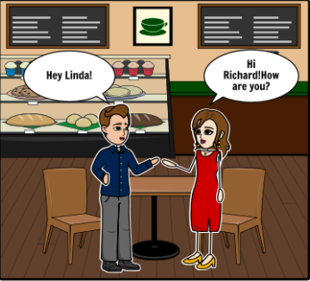

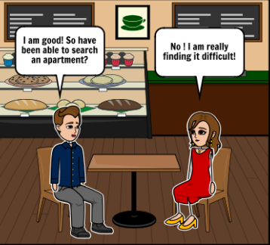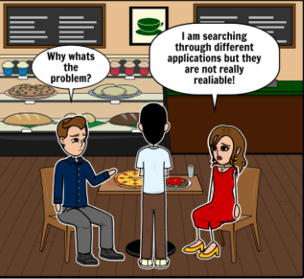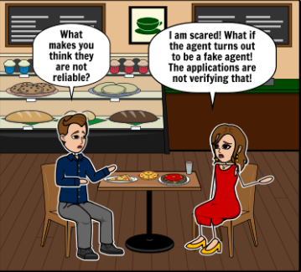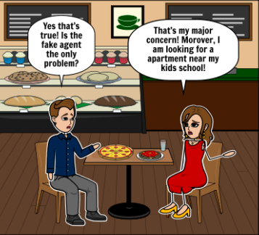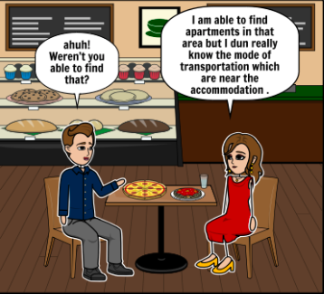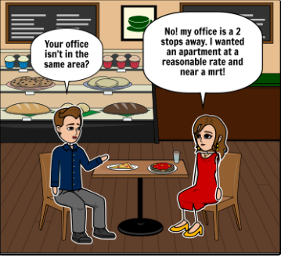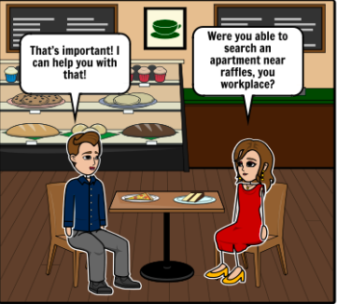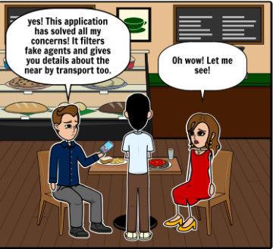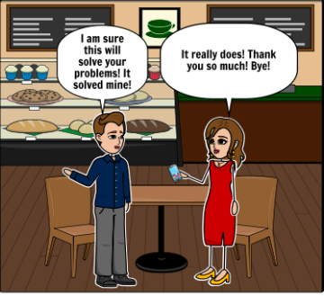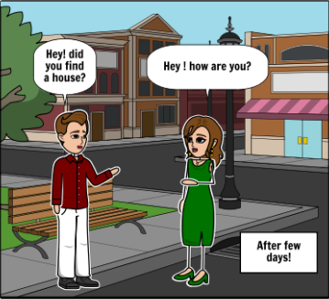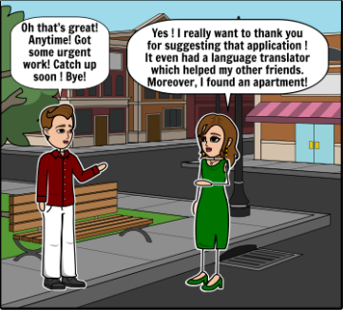

**Prototype Iterations:**

**Prototype and Test (Iteration 1):**

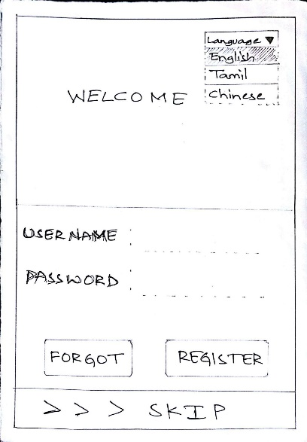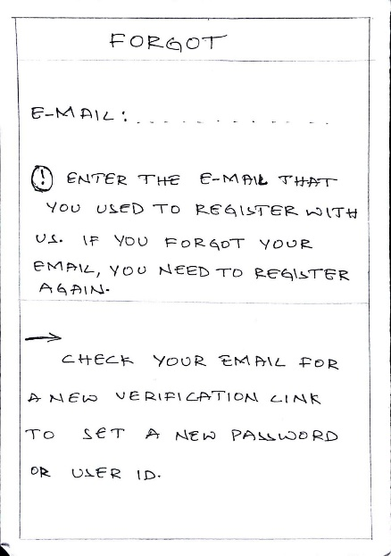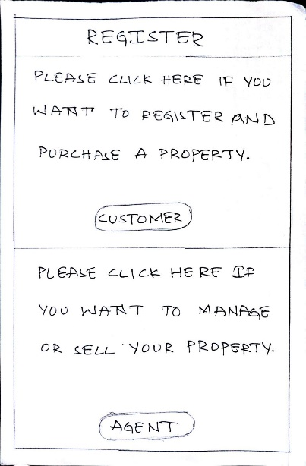

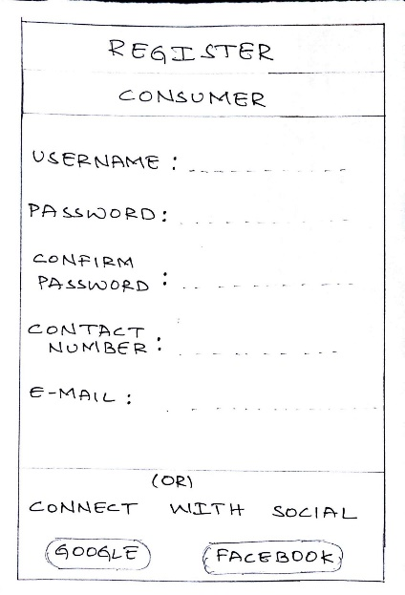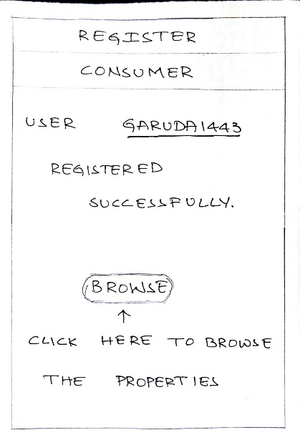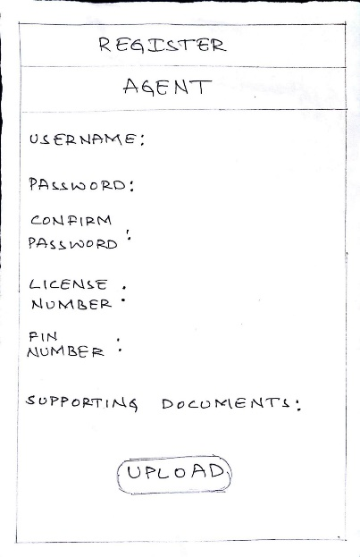

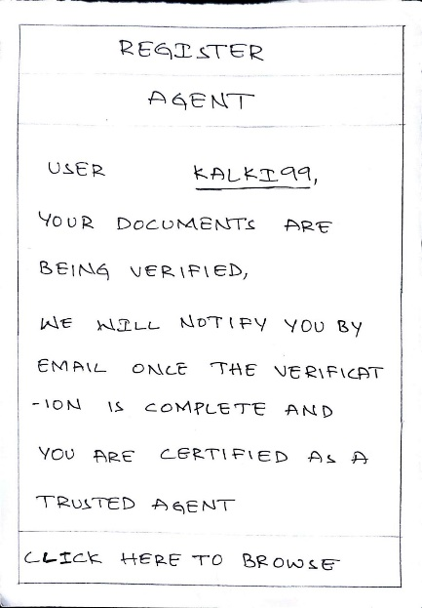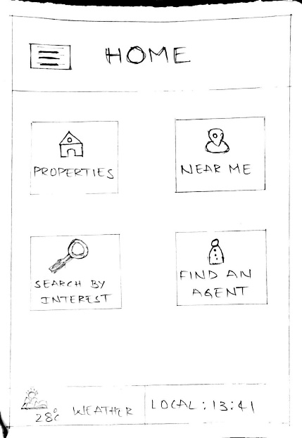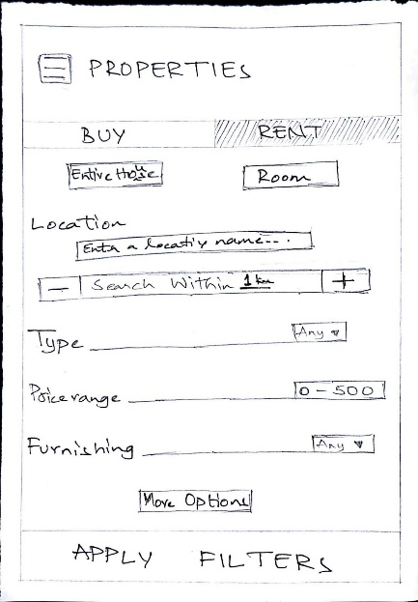

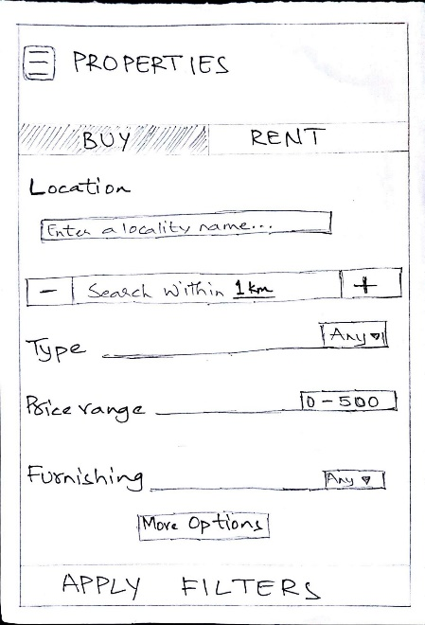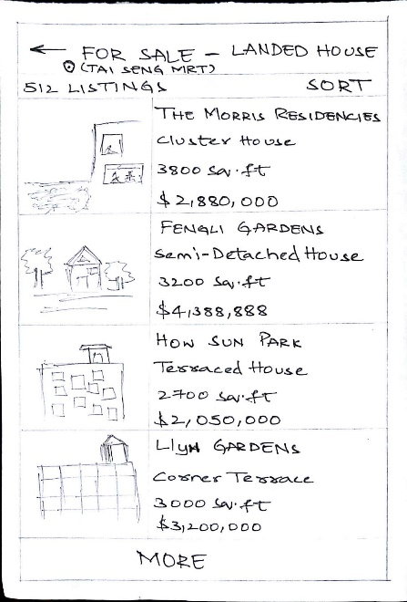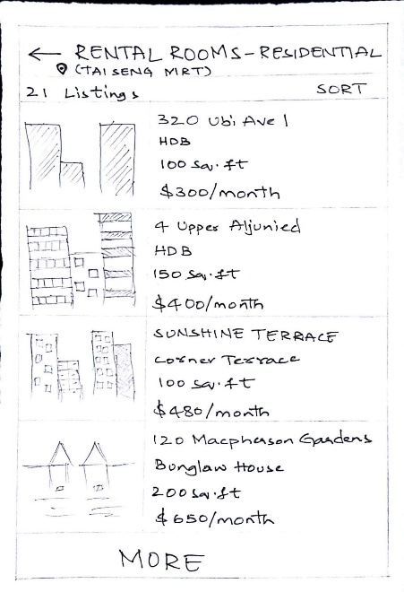

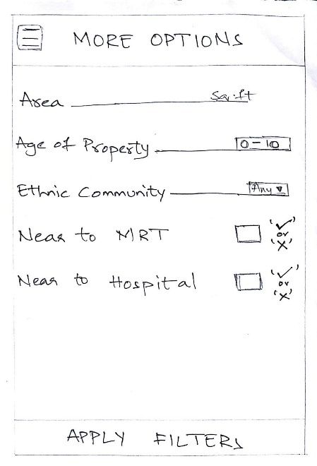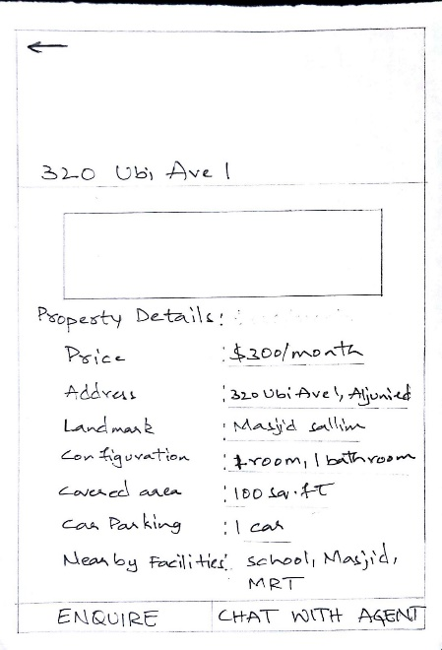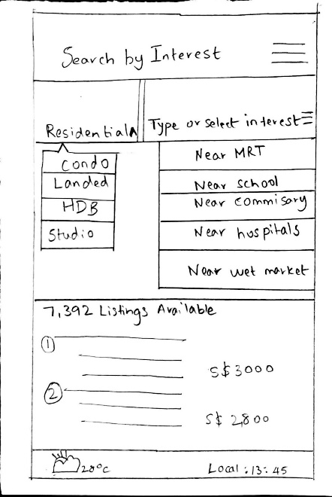

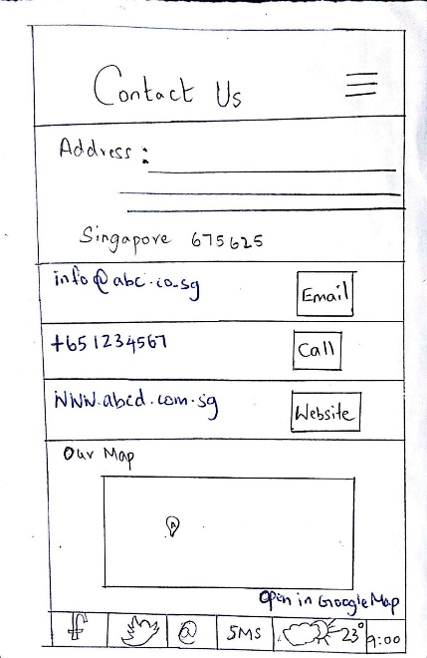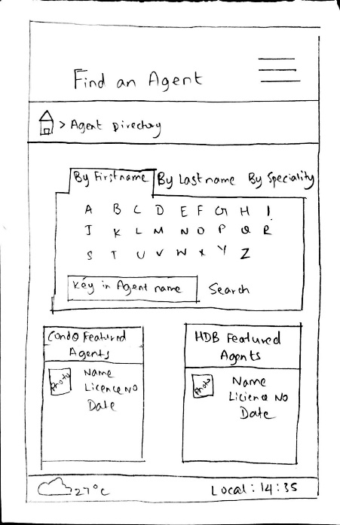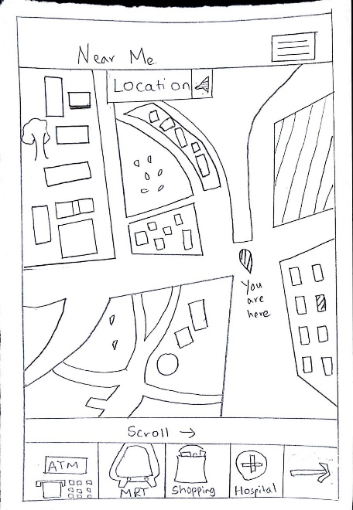

**Testing:**

Conducted a user test on the first iteration by showing the user the prototype and requesting them to use it. The user suggested a few things based on the iteration test. The user was vague about the product regarding what to do and how to navigate as it was a paper prototype. The user was concerned that the property viewing page does not show what are all available in that house, like furniture, features, etc. One of the team members testing revealed that the user was at times unable to understand some of the features in the app, like near me and search feature, and asked the tester to explain the workings of each page. It was also found that less interest was shown regarding the filtering fake agents feature and the user didn’t seem to appreciate it much. And the user didn’t like the way property page was designed, regarding why do they need to click that page and choose buy and rent option again.

**Insights:**

1) Property viewing page was missing the feature that lists down what are all the features and furniture available in the house.

2) Users would like a more understandable prototype design.

3) The users liked the language feature of the product, they were excited about how they can even browse the whole app in their own language. So it was a good feature that was implemented.

4) There was a confusion regarding the “near me” feature and the “search” feature, so the team worked on what to do regarding that.

5) Users liked the option to choose a house near their ethnic community while looking for a property.

6) “Find an agent” feature was given some positive feedback.

**Changes to the next prototype**

1) Making a digital version of the prototype based on the paper prototype and sketches.

2) Merging “near me” feature with “search” feature and making a new one, “search by interest”.

3) Deleting “properties” feature and splitting it into “buy” and “rent”.

4) Adding colors to make the design more appealing to the users.

5) Changing the design of the “find an agent” feature and adding ratings to the agents.

6) Changing the placement of the “ethnic community” option and placing it in a more appropriate feature.

**Some of the things that we would like to add to the insights:**

***What did the users value the most?***

* Users were impressed with so many features included in the prototype. They felt that features like the ‘language’ translator and having the option to search for properties near their ethnic community locations was of paramount importance to them.

***What got them excited?***

* The ‘Search’ page got the users most excited. They said it will be extremely beneficial to them in finding a home near their own ethnic community and MRTs.

***What would convince them about the idea?***

* The idea to have an immigrant-specific mobile app that helps the user find a suitable home near their own place of interest seemed like a plausible idea for the users. They felt it was a feature that they always looks out for but never found in similar housing apps.

The following pages were added/modified after the first iteration.

**Prototype and Test (Iteration 2)**

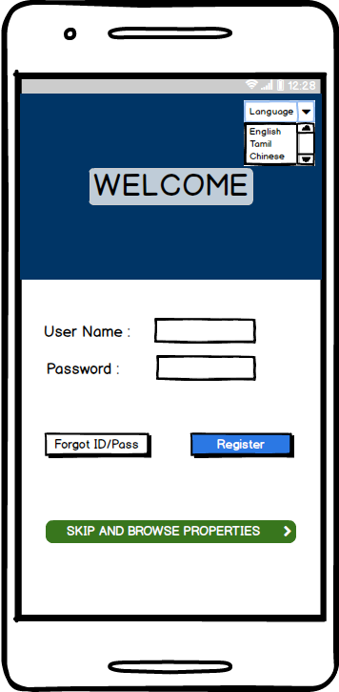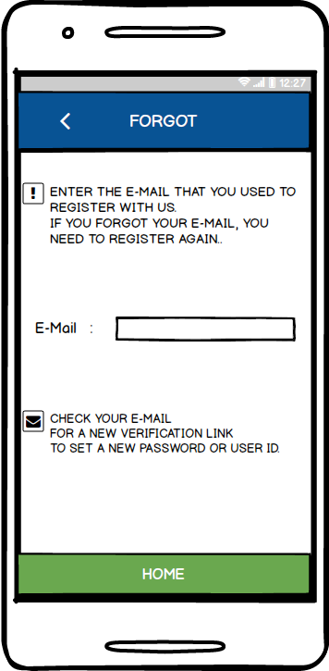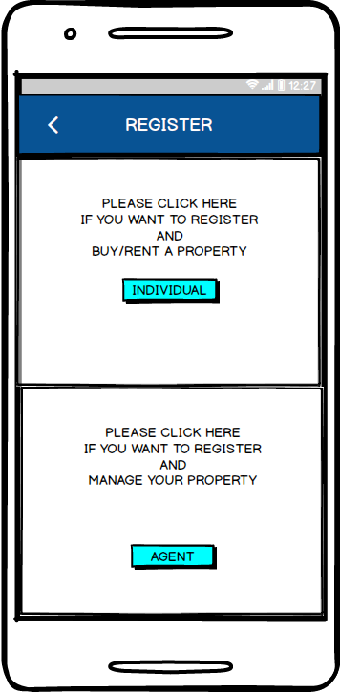

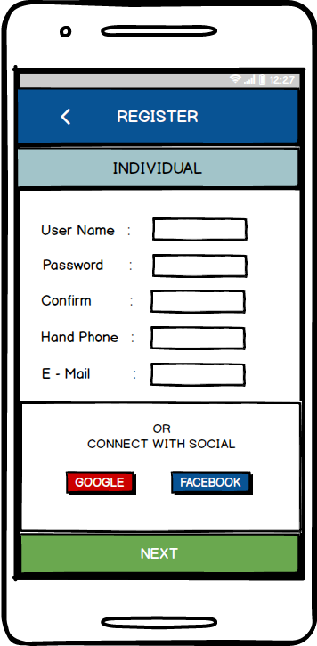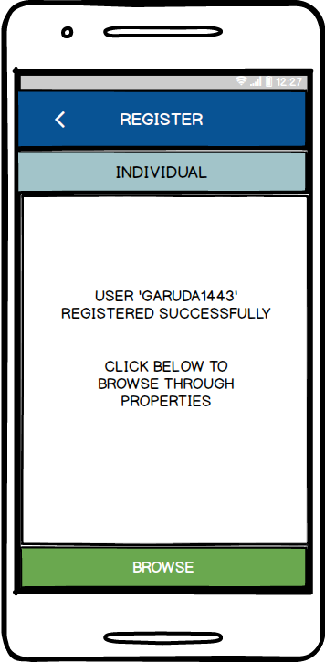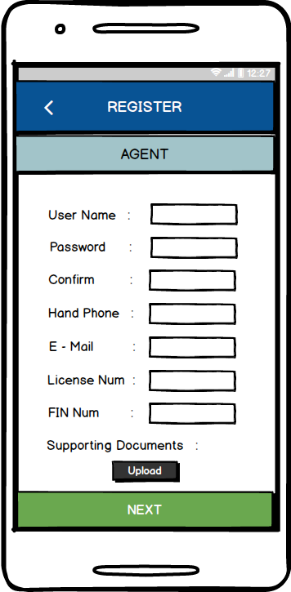

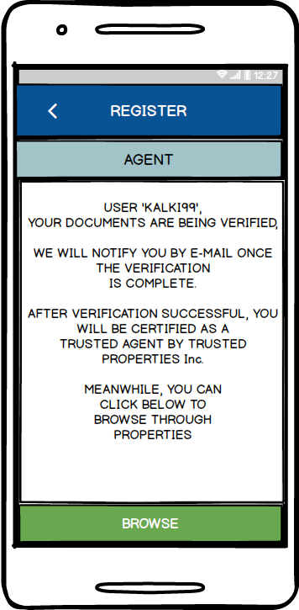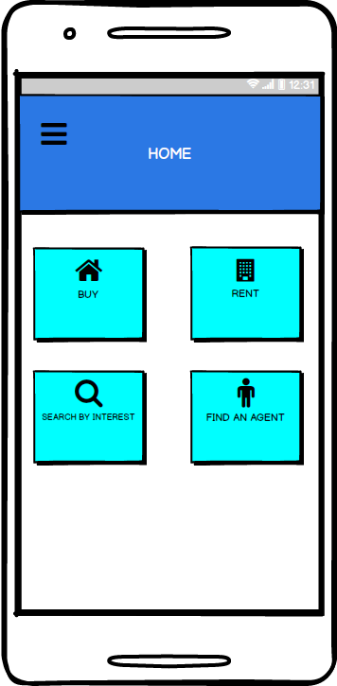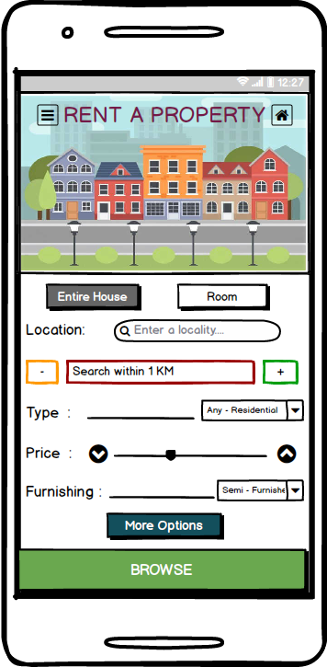

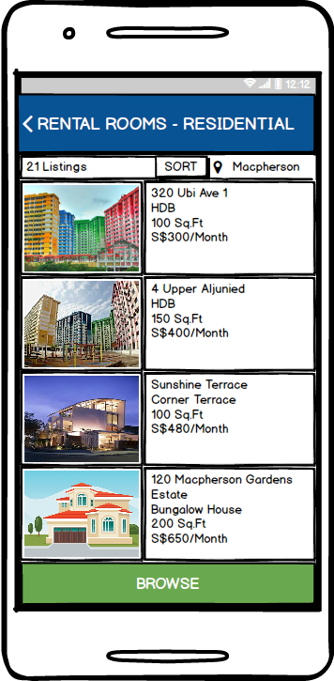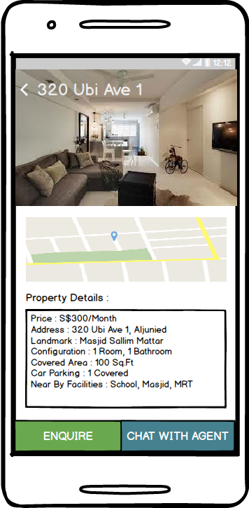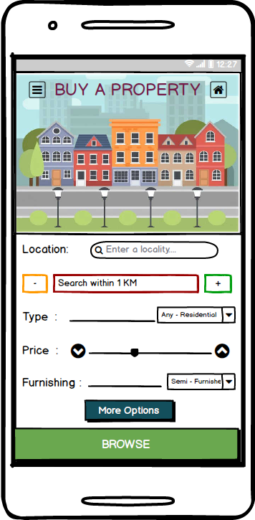

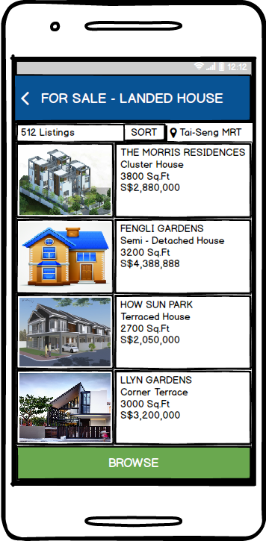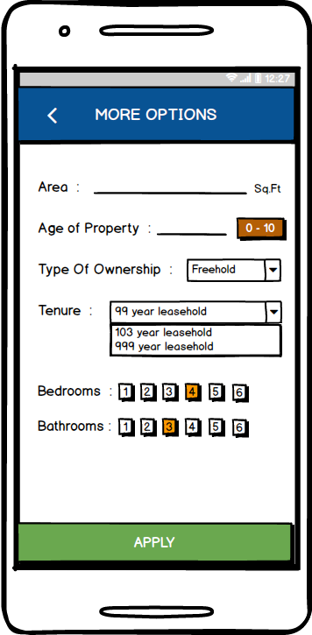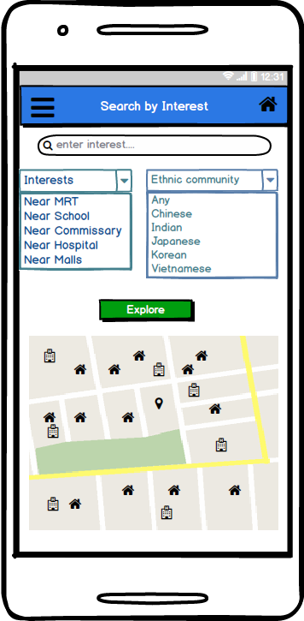

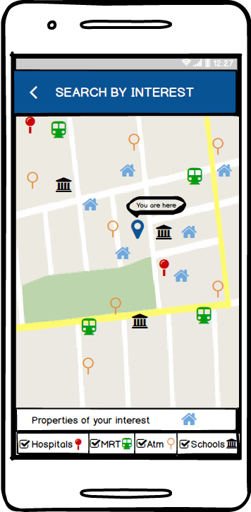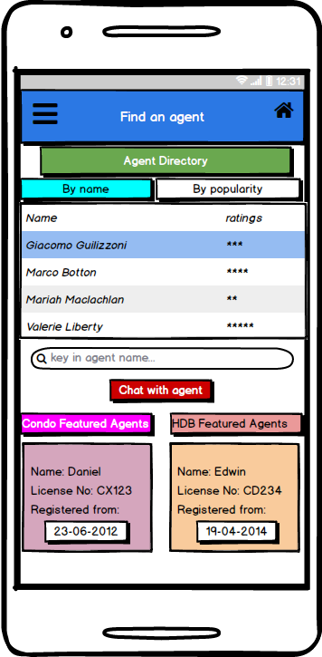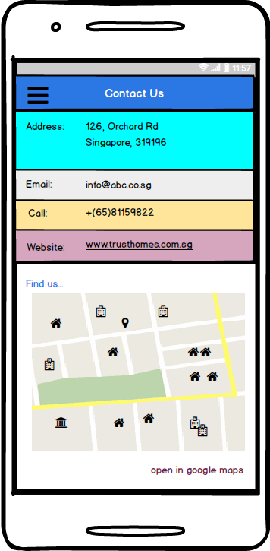

**Testing:**

Conducted the user testing for iteration 2 by showing users the prototype and asking them for their inputs. A few minor additions were mentioned in this testing phase. Users were very impressed with the design of the prototype. Users mentioned that there is no option to browse new properties directly from the “home” page. Some users asked about how to give feedback and contact the company regarding any issues with the app. Users didn’t seem to be interested in “find an agent” feature as we hoped.

**Insights:**

1) Although “find an agent” feature was given some positive feedback during the first prototype user testing, the users didn’t seem to be interested in that feature of the app that much.

2) Users liked the design of the prototype and were very impressed by it.

3) The new “search by interest” page got a very good feedback and was liked by most users during testing. This can be said as the most popular feature of the app.

4) Digital version of the prototype bought up a lot of design changes and made the product appealing to the users.

5) Users would also like to see new properties in the market when they open the app. This was discussed among all the team members, regarding adding a new feature for this.

**Changes to the next prototype:**

1) More refinements will be made in terms of design such as adding dropdown menus rather than text fields and placing home button and menu button in every page.

2) A new feature will be added called “new listings” which will let the user browse all the new properties added.

3) Deleting “find an agent” feature as it didn’t seem to attract any users and no one was interested in using that feature.

4) A side menu with options like, “feedback”, “settings”, “language” and “tips & help” is added.

5) A new welcome page where a user can choose the language initially will be added.

6) New login and register pages will be made to support the design of the app better in terms of feasibility.

**Some of the things that we would like to add to the insights:**

***What did the users value the most?***

The users were extremely impressed with the digital version of the prototype. They said the basic design layout was impressive and all the important features have been highlighted properly. The transformation from paper to digital seemed like a convincing idea to them, and they were able to identify different aspects of the pages in a much more efficient manner now.

***What got them excited?***

The feature ‘Search by Interest’ got the best feedback from the users.

***What would convince them about the idea?***

The users felt having a direct chat options with the agents is beneficial to them as they don’t usually find it in the existing apps.

The following pages are added/modified after the second iteration

**Prototype 3:**

The users were satisfied with all the features incorporated within the app. This was an actual working of the app as it was user-tested with the help of the marvel app interactive tool. The user was delighted to use a navigation tool to access each and every page. This was a change of perspective that helped garner good comments from the user. The user mentioned no additional changes that were to be necessitated in the final design. However, the team came up with the idea of incorporating some additional features for future development. These include a 3D map, and video chatting interface with the users and the agent /house owners. These ideas were still in the beginning stage and cannot be implemented in the context of the present design. Our final prototype images with all the changes is illustrated below.

**Images of the final prototype:**

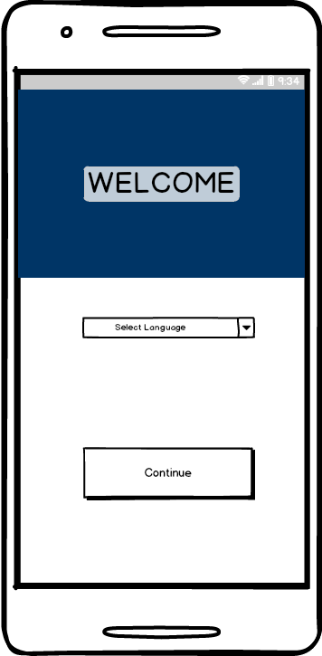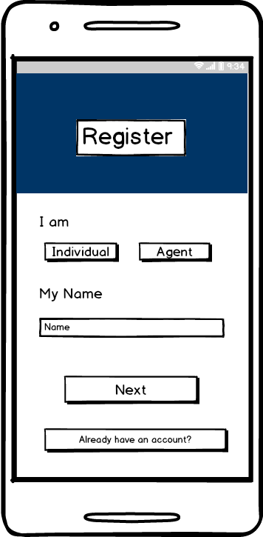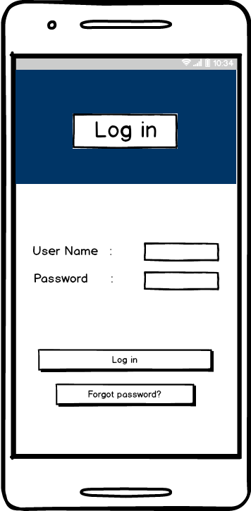

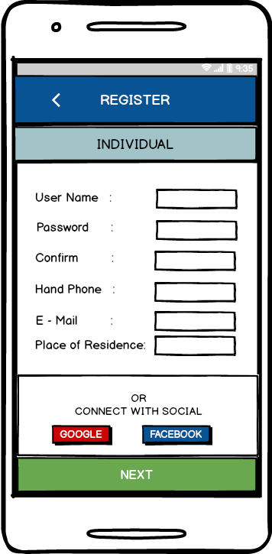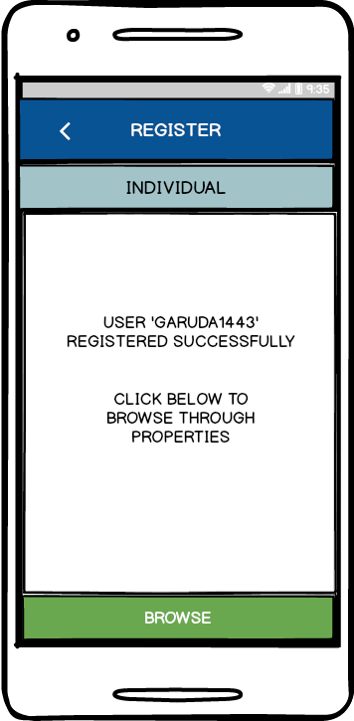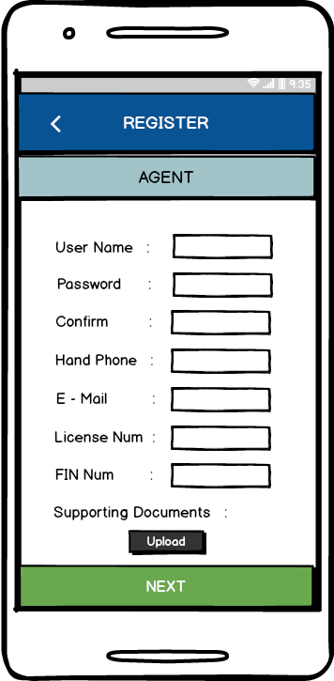

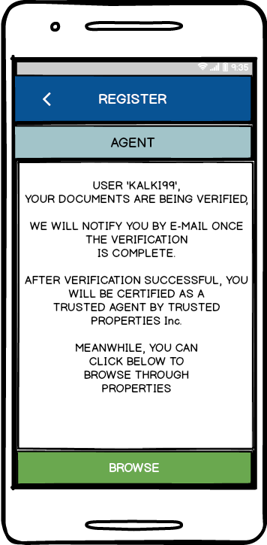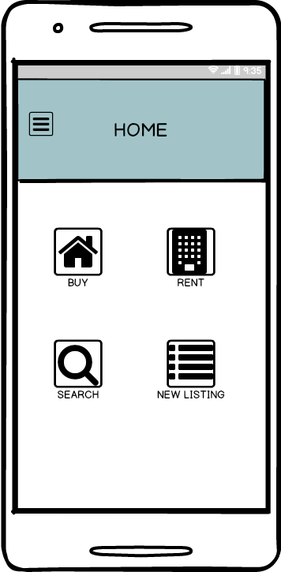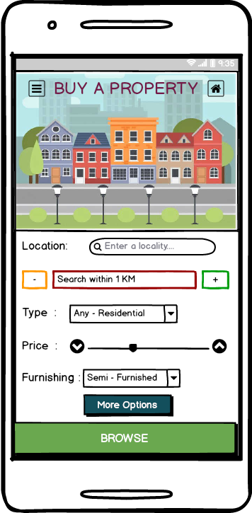

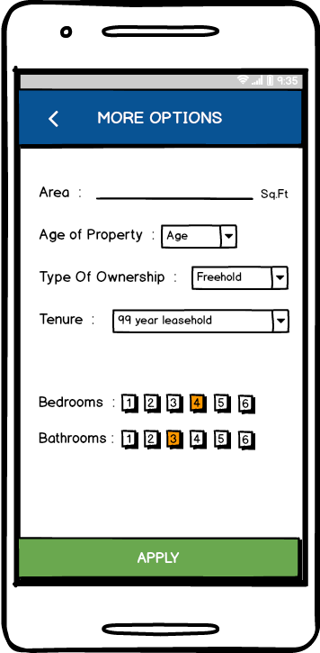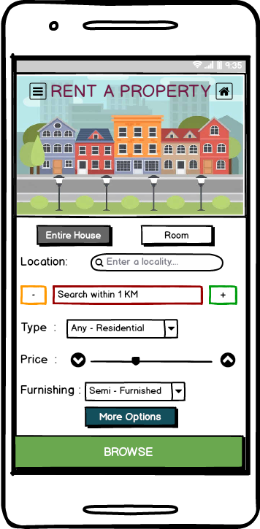



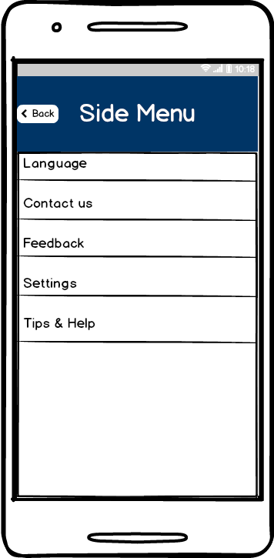

**Minutes of the meeting:**

|  |  |  |
| --- | --- | --- |
| Topic | Plan | Objectives (<50 words) |
| Storyboard | Date :29th December 2016  Time: 3:00 pm to 6:00 pm  Venue: Student Hub | To create a story board indicating the problems the user may face |
| Sketching, Interview | Date: 2nd January 2017  Time: 6:00 pm to 7:30 pm  Venue: Student Hub | Making the storyboard, and deciding features for the application |
| Interviews, Iteration 1 | Date :5th January 2017  Time: 2:00 pm to 5:00 pm  Venue: Student Hub | Conducting interviews and preparing prototype 1 |
| User Testing, Iteration 2 | Date: 9th January 2017  Time: 12:00 pm to 2:30 pm  Venue: Student Hub | Performing user testing and making prototype 2 |
| User Testing, Final Iteration | Date :12th January 2017  Time: 5:00 pm to 7:00 pm  Venue: Student Hub | Performing user testing and making prototype 3 |

**Meeting 1:**

Name of Team:   
Date of meeting: 29th December 2016 3:00 pm to 6:00 pm   
Members present: All team members  
Members absent: None  
Meeting chairperson: Uday  
Minutes taken by: Surya  
Summary of meeting:

We gathered and discussed the comments given for assignment 1. We than changed the outcomes and then decided to create a story board. We discussed the ideas which could be used to make the story board. We concluded the meeting with deciding to make rough sketches for the story board.

Action items for Team members:

|  |  |  |
| --- | --- | --- |
| Actions to Do | Who will do this work? | By when? |
| Create a google document | Vihangi | Same day |
| Research on the topic | All team members | Next meeting |
| Rough sketches | All team members | Next meeting |

Next meeting date and time: 2nd January 2017 6:00 pm to 7:30 pm

**Meeting 2:**

Name of the Team :

Date of meeting: 2nd January 2017 6:00 pm to 7:30 pm   
Members present: All team members   
Members absent: None  
Meeting chairperson: Sudheer  
Minutes taken by: Uday  
Summary of meeting: (what has been discussed, decisions made)

The meeting started with all the team members showing their rough sketches. The rough sketches were than discussed. We than combined the rough sketches and made a rough sketch. The final sketch was to made by the next meeting. We also discussed the kind of interview questions we must ask. Upon listing down all the questions, we chose the 12 questions which would be the most suitable. The meeting concluded with noting the interview questions.

Action items for Team members:

|  |  |  |
| --- | --- | --- |
| Actions to Do | Who will do this work? | By when? |
| Making the final storyboard | Vihangi | Next meeting |
| Conducting interviews- 2 each | All team member | Next meeting |
| Scripting | Uday | Next meeting |

Next meeting date and time: 5th January 2017 2:00 pm to 5:00 pm

**Meeting 3:**

Name of the team :

Date of meeting: 5th January 2017 2:00 pm to 5:00 pm   
Members present: All team members  
Members absent: None  
Meeting chairperson: Vihangi   
Minutes taken by: Spurgeon  
Summary of meeting: (what has been discussed, decisions made)

The meeting started with each of discussing the results of the interviews. On analysing the interview questions we understood the need of the users, through which we listed down a number of features. Through these features, we made rough sketches of the first prototype.

Action items for Team members:

|  |  |  |
| --- | --- | --- |
| Actions to Do | Who will do this work? | By when? |
| Prototype 1 | All team members | Next Meeting |
| Perform user testing – 2 each | All team members | Next Meeting |
|  |  |  |

Next meeting date and time: 9th January 2017 12:00 pm to 2:30 pm

**Meeting 4:**

Name of Team:  
Date of meeting: 9th January 2017 12:00 pm to 2:30 pm  
Members present: All team members  
Members absent: None  
Meeting chairperson: Surya  
Minutes taken by: Vihangi  
Summary of meeting:

The meeting started with discussing the feedback which we got from prototype 1. Than we made rough sketches for iteration 2. Upon creating these images , we decided to perform the user testing.

Action items for Team members:

|  |  |  |
| --- | --- | --- |
| Actions to Do | Who will do this work? | By when? |
| Prototype 2 | Sudheer, Uday | Next meeting |
| User Testing – 2 each | All team members | Next meeting |
|  |  |  |

Next meeting date and time: 12th January 2016 5:00 pm to 7:00 pm

**Meeting 5:**

Name of Team:  
Date of meeting: 12th January 2017 5:00 pm to 7:00 pm  
Members present: All team members  
Members absent: None  
Meeting chairperson: Spurgeon  
Minutes taken by: Sudheer  
Summary of meeting:

The meeting started with discussing the results of iteration 2. The feedbacks seemed to be positive. Only a minor changes were required, in terms of design. We created the images and incorporated it using the marvelapp software and concluded the meeting. We than proceeded to complete the individual assignment.

Action items for Team members:

|  |  |  |
| --- | --- | --- |
| Actions to Do | Who will do this work? | By when? |
| Prototype 3 | Surya, sudheer | 19th January 2017 |
| Complete the assignment 1 | All team members | 19th January 2017 |
|  |  |  |

Next meeting date and time: --

**Design Studio Process:**

We described how we took on this project in the team collaboration report. The background of whatever has been done during the process is not reported. When we first sat together for the brainstorming session, we framed a lot of questions ourselves and then we began to search for answers by discussing it with the group. We curated all the answers we collected and understood how to approach the topic. We hypothesized and made assumptions after that.

During the assumptions phase and the hypothesis writings, we discussed on how a feature might be helpful, how to make it better, easier and more interactive for the user. Most of the time is spent on criticizing various scenarios of the topic.

Design of the product was sketched after the assumptions have been made. During the sketching process, we researched upon the best design techniques to take up and make the product. We took a lot of ideas from the team and worked on the most appropriate/suitable ones. We were not trying to solve the problem here, we were rather thinking about ways to approach the solution and get the best result. Most of the lean UX process time was spent on design. Iteration after iteration to make a feasible and refined product. The result was much appreciated and to put in  a common word format, ‘clean’.

The design of the product only gave us a product that is refined and most efficient one, the emerging ideas about new features that can be incorporated into the product were astonishing. User testings and new knowledge about the product helps improve the product a lot.

**Evidence of Collaborative Design:**



